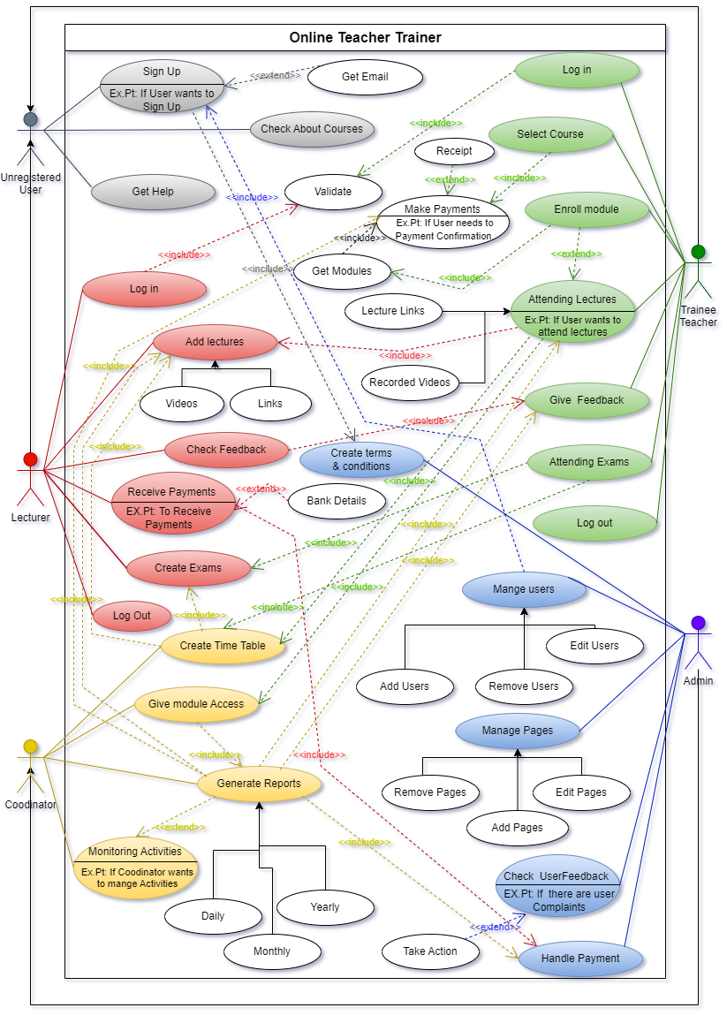

|  |  |  |
| --- | --- | --- |
| **IT22144430** | | |
| **Use case ID** | OTT_UU_0001 | |
| **Use case Name** | Sign Up | |
| **Summary** | Registration of Trainee Teachers and Lecturers | |
| **Priority** | 1 | |
| **Preconditions** | The user should have a valid email | |
| **Primary Actor(s)** | Unregistered User | |
| **Trigger** | The user wanted to register for the online Teacher Trainer System | |
| **Main Scenario** | **Step** | **Action** |
| **1** | Go to the online teacher trainer |
| **2** | Select sign-in as Trainee Teacher or Lecturer |
| **3** | Sign in with an Email and Password |
| **4** | Enter the following information on the webpage as required by the user,   * First name * Last name * Address * NIC * Mobile Number |
| **5** | Select Course or Modules (Trainee Teacher selects a Course hope to learn and Lecturer selects Modules to hope to teach) |
| **6** | Accept Terms and Conditions |
| **7** | Click on Submit button to Submit details |
| **Extensions** | **Step** | **System Action** |
| **3a** | If the email is not valid, the system prompts an error |
| **7a** | If the user wants to submit the form, the system prompts a confirmation |
| **Open Issues** | **7** | Should the system ask if the user wants to read the terms and conditions? |

|  |  |  |
| --- | --- | --- |
| **IT22144430** | | |
| **Use case ID** | OTT_TT_0003 | |
| **Use case Name** | Attending Exams | |
| **Summary** | Attending exam to the trainee teacher | |
| **Priority** | 1 | |
| **Preconditions** | The user must pay for the course | |
| **Primary Actor(s)** | Trainee Teacher | |
| **Trigger** | The user wanted to attend the exams | |
| **Main Scenario** | **Step** | **Action** |
| **1** | Go to the online teacher trainer |
| **2** | Log in to the system using the given credentials |
| **3** | Get the exam schedule using the timetable button |
| **4** | Find exam schedules from it.   * Assignment * Mid exam * Final exam |
| **5** | Get the exam links from the schedule before starting the exam |
| **6** | Log in to the exam using the given credentials and given enrollment key |
| **7** | Read instructions and attempt the exam |
| **8** | Finish the exam and submit |
| **Extensions** | **Step** | **System Action** |
| **2a** | If the email is not valid, the system prompts an error |
| **6a** | If the enrollment key is not valid, the system prompts an error |
| **8a** | If the user submits the exam, the system prompts submitted |
| **Open Issues** | **7** | Should the system ask if the user wants to the check answers? |

**IT22144430 - Liyanage N S**

**Section worked on:**

* Drawing the use case diagram.
* Draw a use case scenario for the Unregister user and trainee Teacher.

**Special contribution on:**

* Help others to complete their use case scenario.
* Help others to create use cases.

**Challenges Faced:**

* Difficult to find the relations among the use cases.
* Difficult to gather group members.